1. [**AZ-204-DevelopingSolutionsforMicrosoftAzure**](https://github.com/MicrosoftLearning/AZ-204-DevelopingSolutionsforMicrosoftAzure/tree/master)/**AZ-204_lab_02.md**

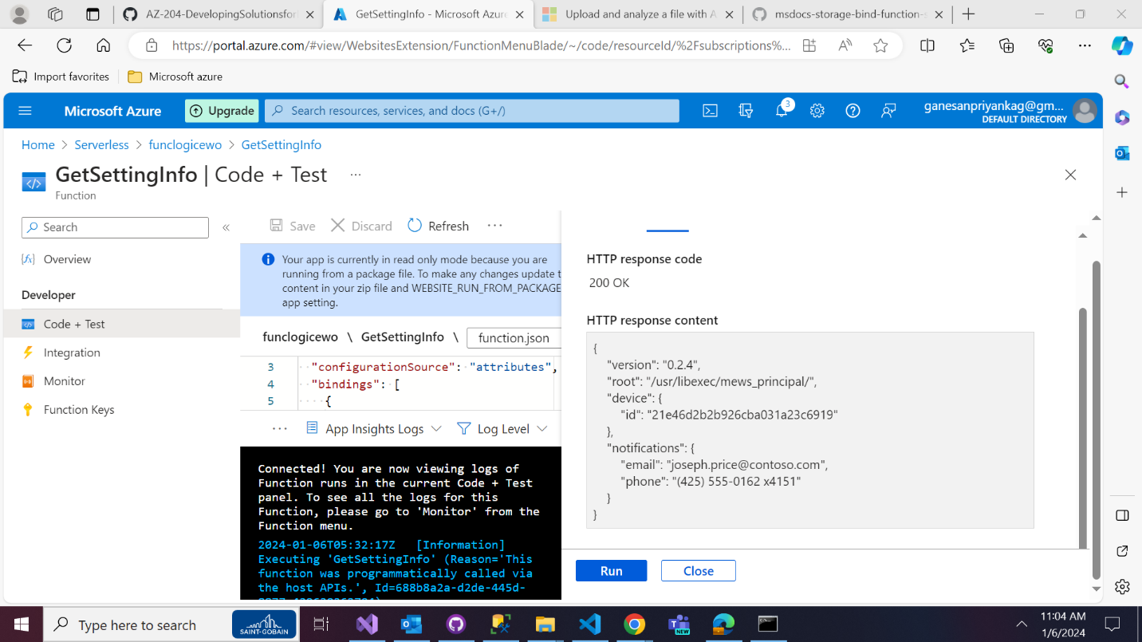

# Upload and analyze a file with Azure Functions and Blob Storage

